**Name: Ronika Paul**

**Roll No:30**

**Batch: RMCA(B)**

**Date:26/03/2021**

**NETWORKING & SYSTEM ADMINISTRATION LAB**

**Experiment No.: 1**

**Aim**

Familiarization of Linux commands.

**Procedure**

1. **$pwd:** This command is used to print working directory starting from the root.

**Output:**

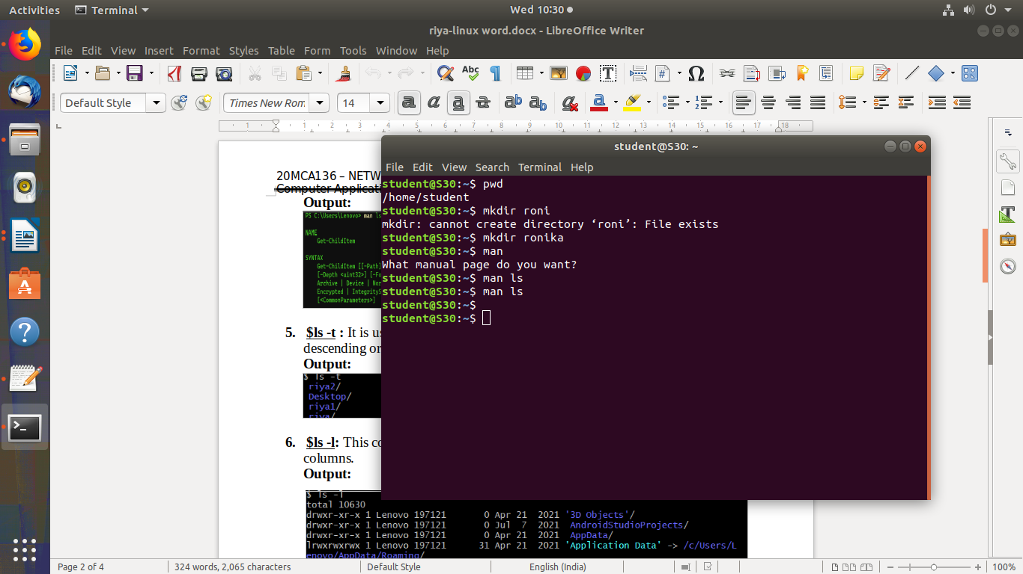

1. **$mkdir:** This command is used to make new directory.

**Output:**



1. **$man:** This command is used to display the user manual of any command that we can run on the terminal.

**Output:**



1. **$man ls:** This command is used to list files or directories in Linux.

**Output:**

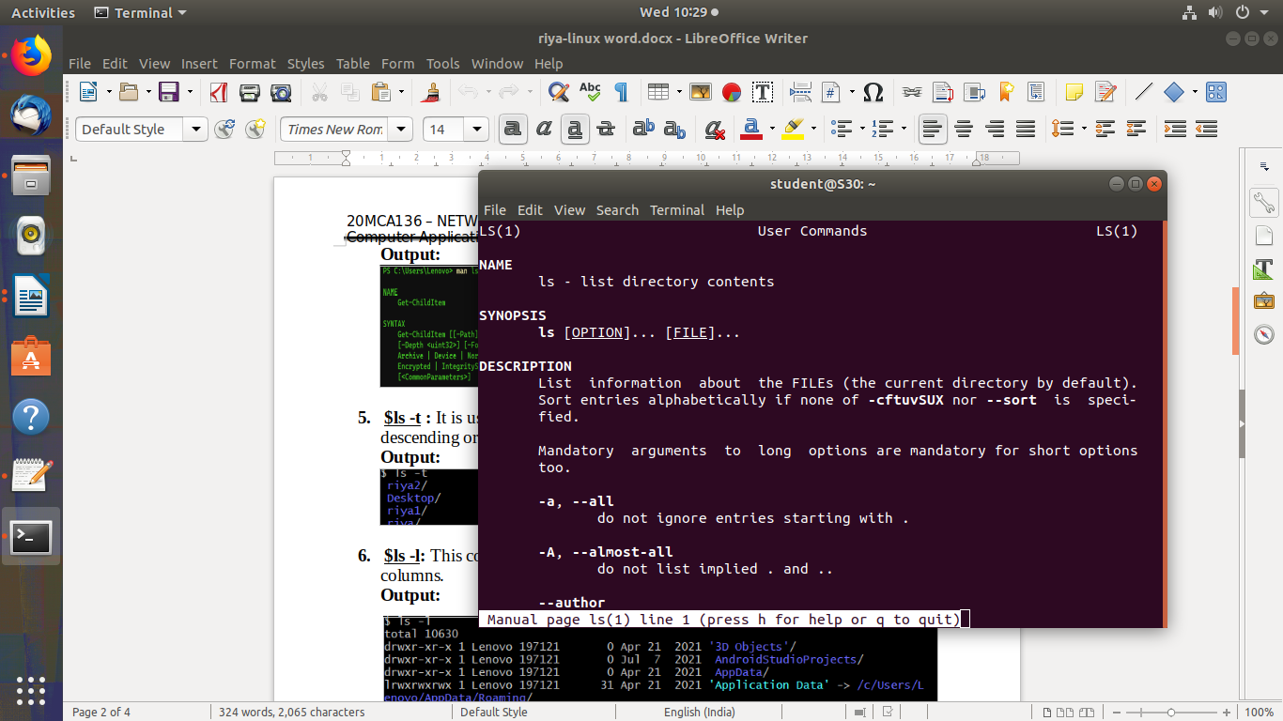

1. **$ls -t :** It is used to list files or directories and sort by last modified date in descending order(biggest to smallest).

**Output:**

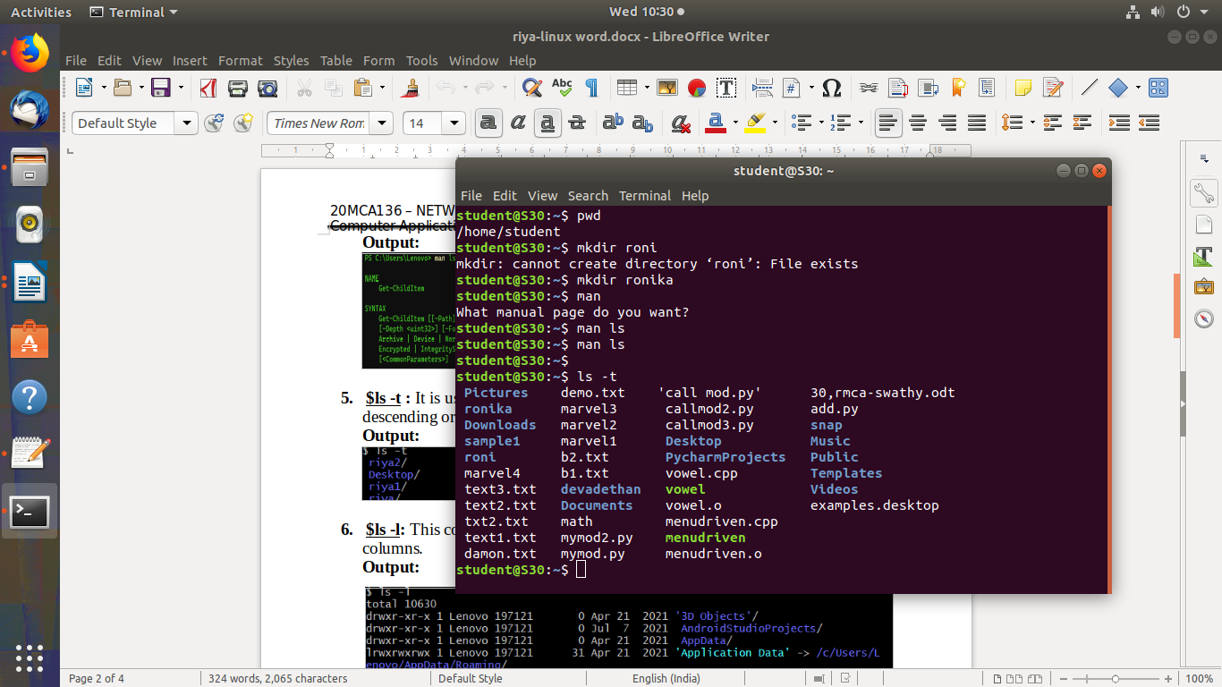

1. **$ls -l:** This command is used to list the contents of directory in table format with columns.

**Output:**

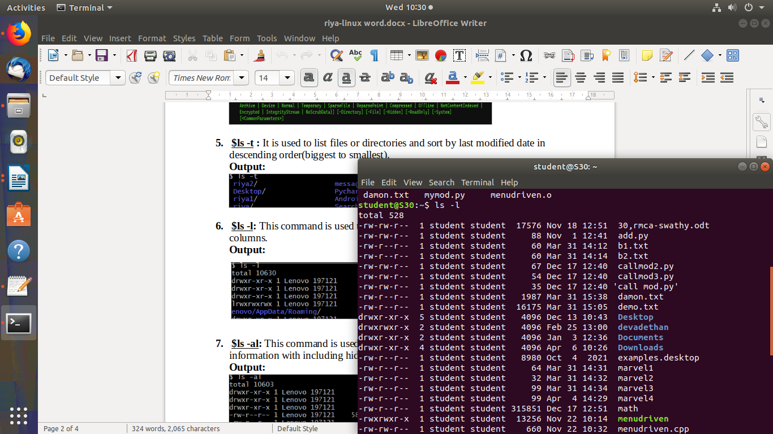

1. **$ls -al:** This command is used to list files or directories in a table format with extra information with including hidden files or directories.

**Output:**

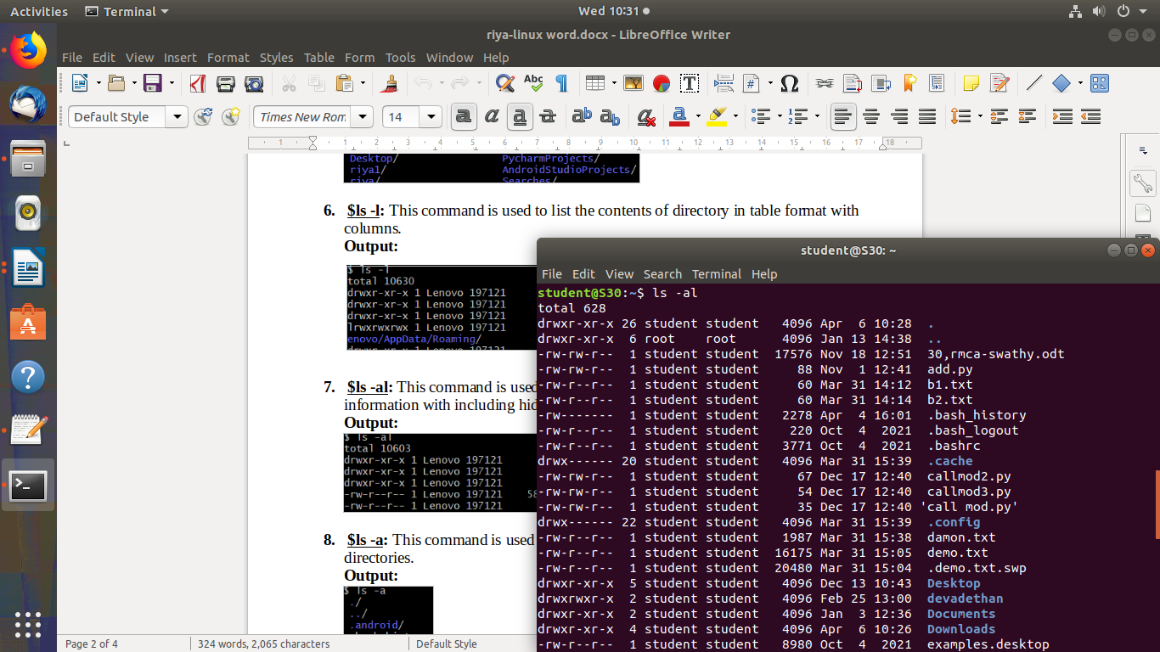

1. **$ls -a:** This command is used to list files or directories including hidden files or directories.

**Output:**

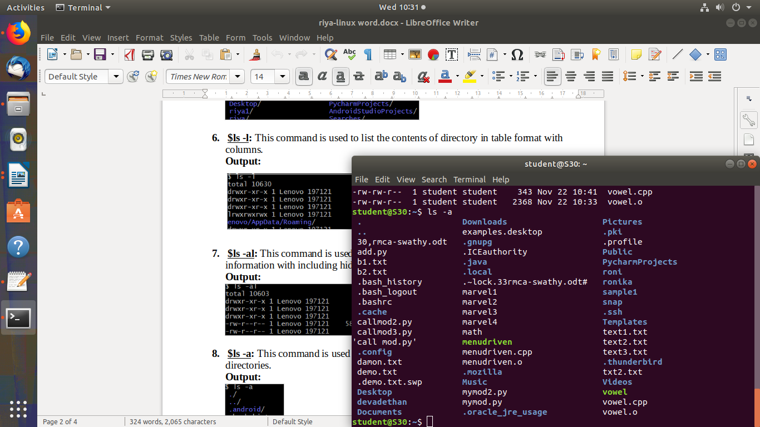

**9. $ls -R:** This command is used to display the contents of subdirectories.

**Output:**

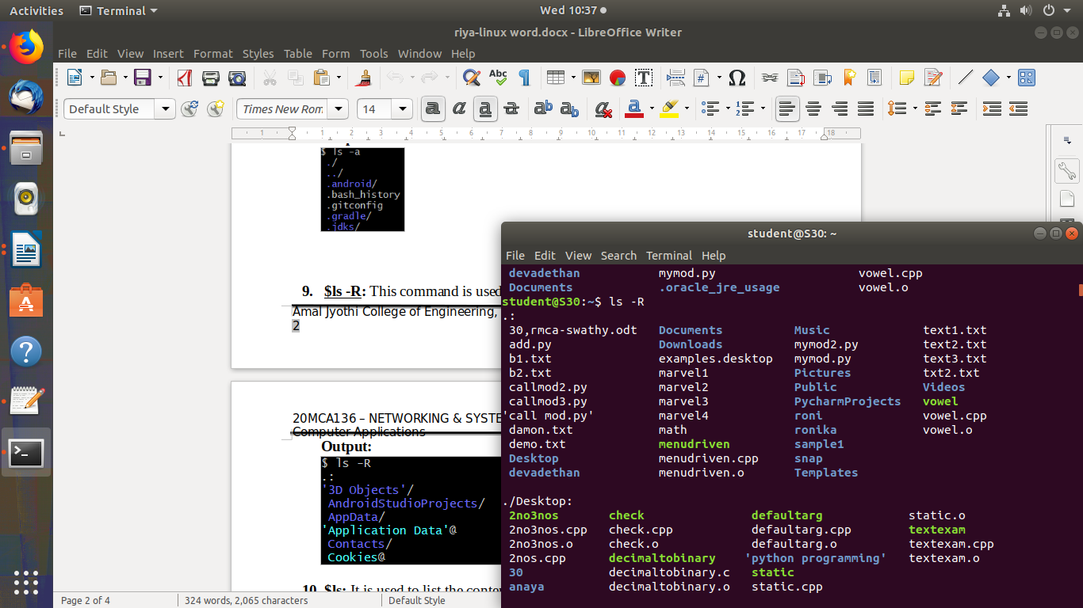

1. **$ls:** It is used to list the contents of current working directory.

**Output:**

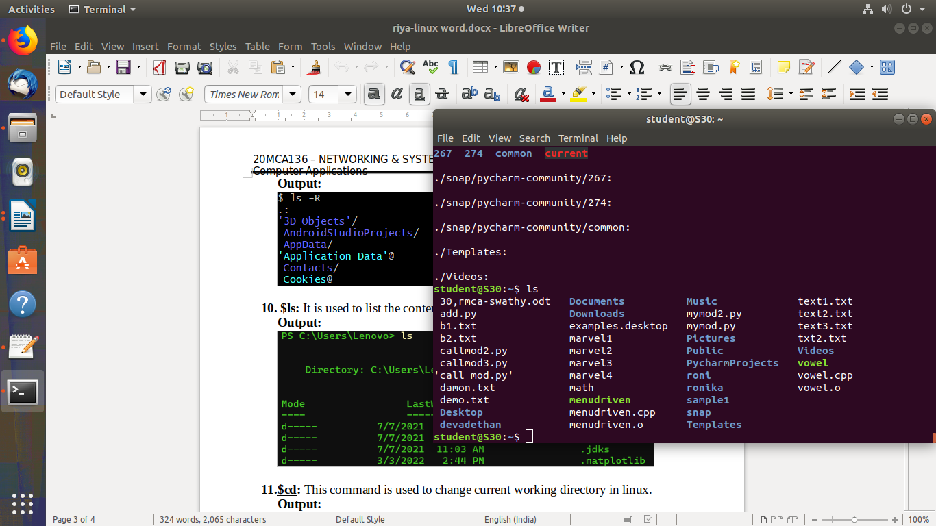

1. **$cd:** This command is used to change current working directory in linux.

**Output:**

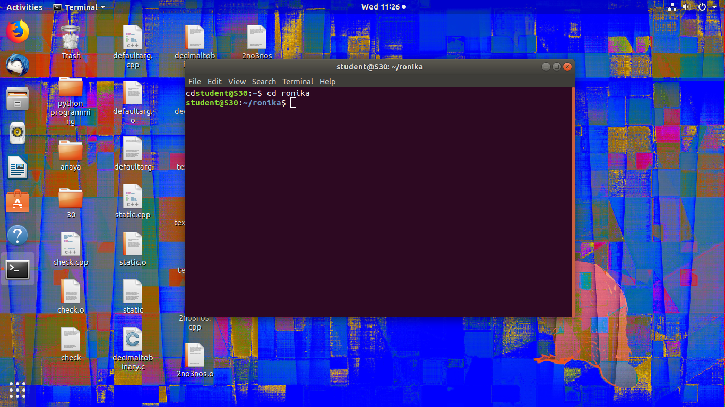

1. **$cd ..:** This command is used to move to parent directory of current directory.

**Output:**

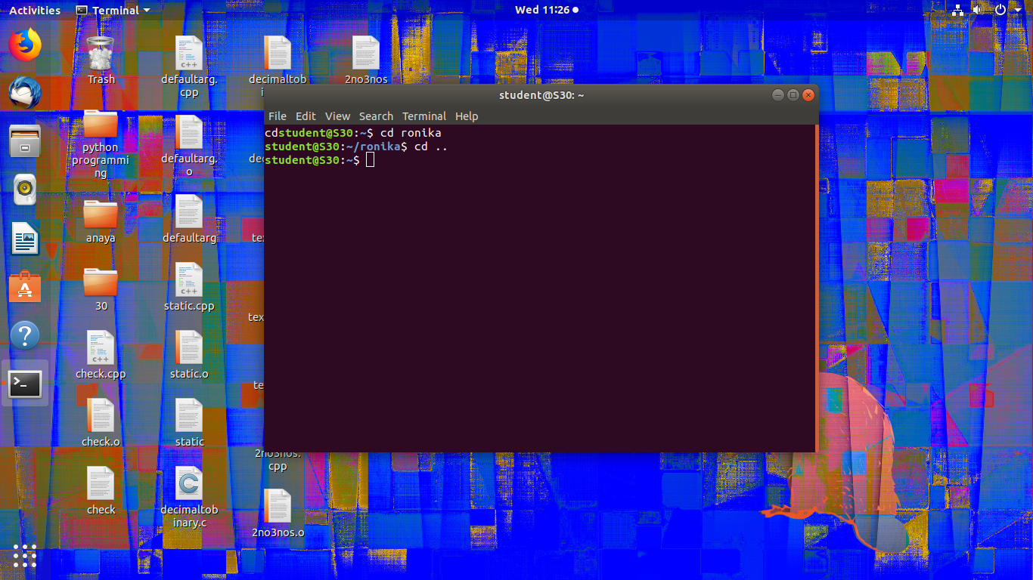

1. **$cd -:** This command is used to change to previous directory.

**Output:**

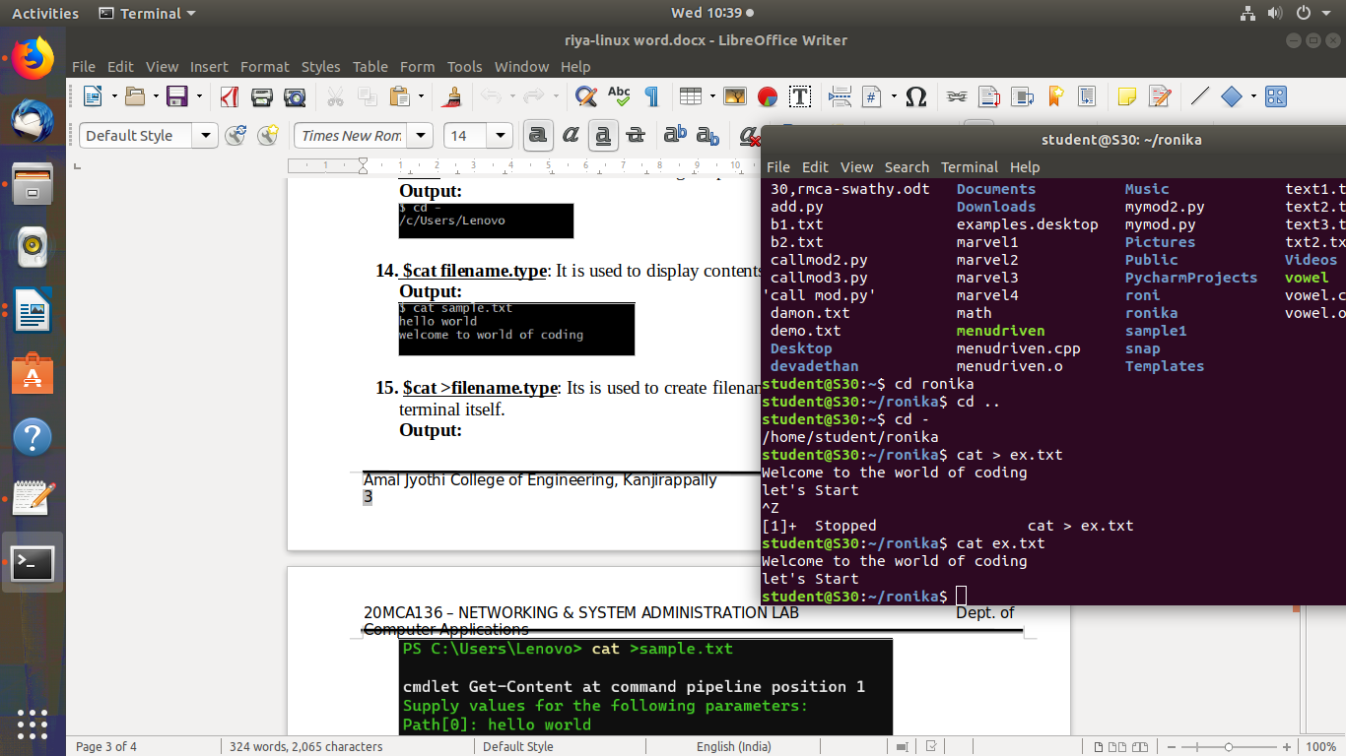

1. **$cat filename.type**: It is used to display contents on the file.

**Output:**



1. **$cat >filename.type**: Its is used to create filename and contents can be added on the terminal itself.

**Output:**



1. **$cat >>filename.type**: It is used to append content to existing file.

**Output:**

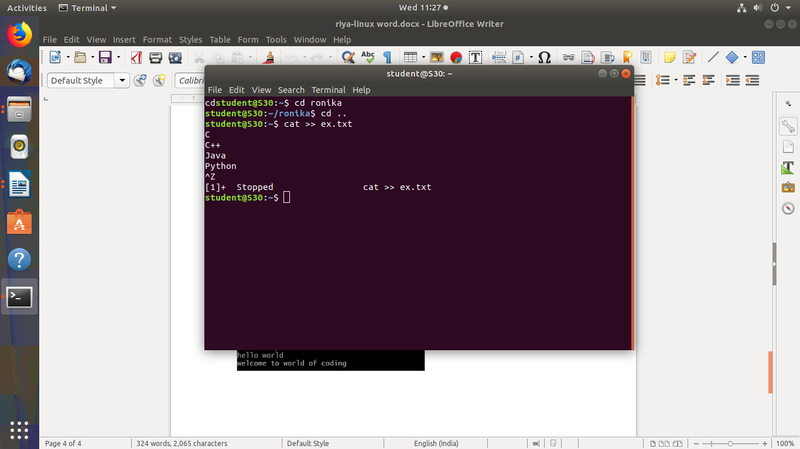

1. **$cat filename.type > filename2.type:** This command is used to copy contents of one file to another file.

**Output:**

